***CSC 212 Programming 200 points***

***Project 4***

Develop a menu-based GUI program to generate a matrix of 75X75 of integers 0 or 1 using the random number generator in the Math class. Use the following formula:

**(int) (Math.random()+0.8)**

Display the original matrix in a grid around the whole matrix and every 5X5 blocks.

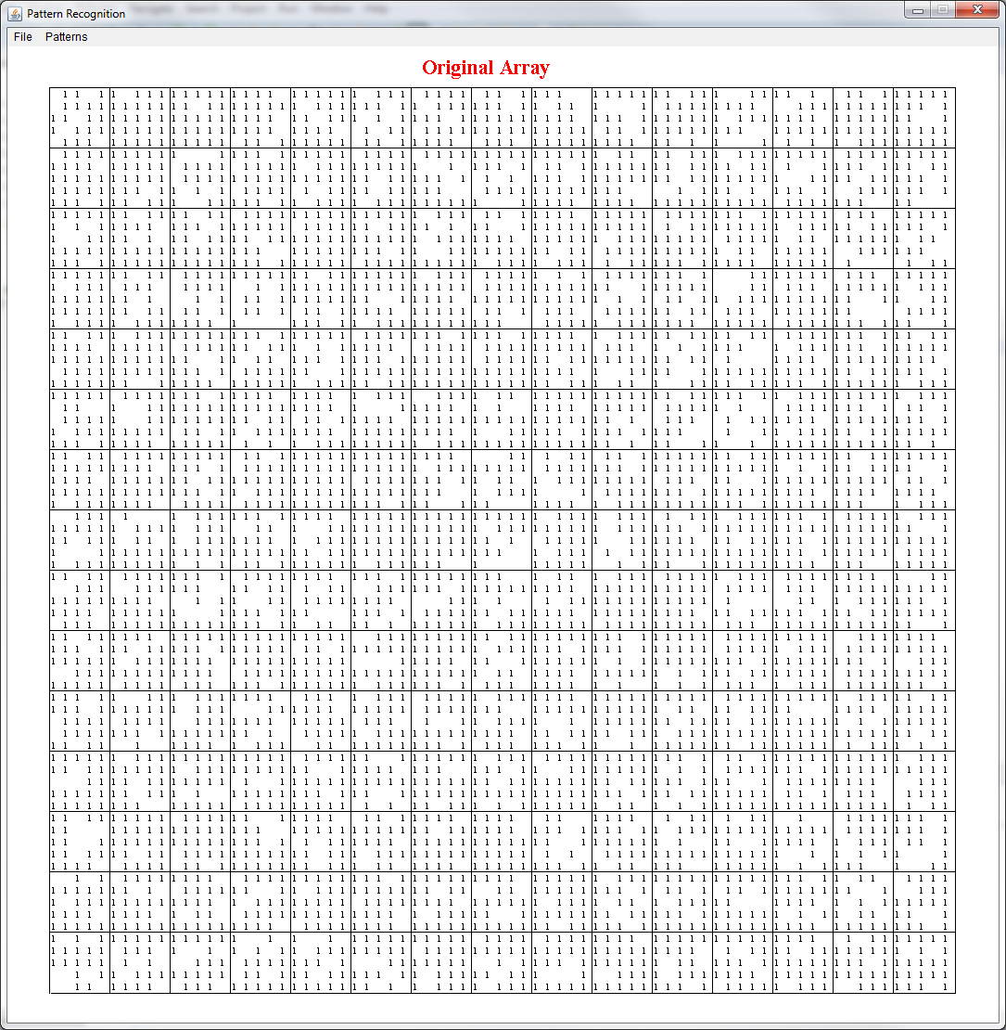

Scan the matrix, check the blocks of 5X5 (there are 20/row and 20/column) for patterns of:

**X= Y=7 Z=13**

|  |  |  |  |  |  |  |  |  |  |  |  |  |  |  |  |  |
| --- | --- | --- | --- | --- | --- | --- | --- | --- | --- | --- | --- | --- | --- | --- | --- | --- |
| **1** |  |  |  | **1** |  | **1** |  |  |  | **1** |  | **1** | **1** | **1** | **1** | **1** |
|  | **1** |  | **1** |  |  | **1** |  | **1** |  |  |  |  | **1** |  |
|  |  | **1** |  |  |  |  | **1** |  |  |  |  | **1** |  |  |
|  | **1** |  | **1** |  |  |  | **1** |  |  |  | **1** |  |  |  |
| **1** |  |  |  | **1** |  |  | **1** |  |  | **1** | **1** | **1** | **1** | **1** |

Mark each pattern with different color:

* X ---- Green
* Y ---- Red
* Z ---- Blue

Draw the matrix after processing it, display only the colored cells.

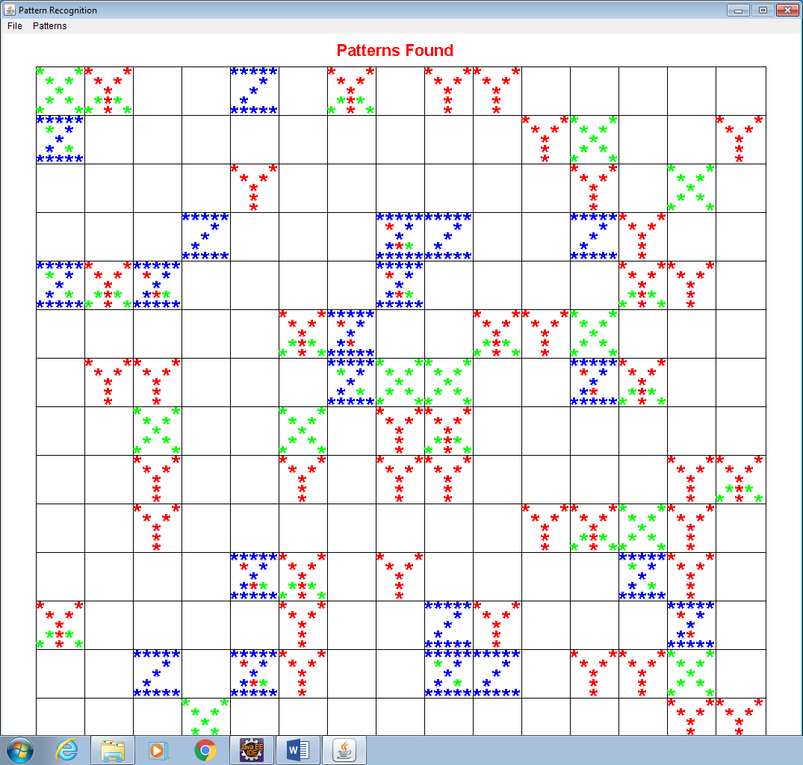

You need at least two classes, one for the program interface (Project03) and another for pattern recognition operations:

* **Generate Original Array**
* **Display Original Array**
* **Detect Patterns**
* **Display Patterns**

**BONUS (20 points): Gray (disable the menu items that are not available, display patterns should be grayed if detect pattern is not invoked yet)**

**Bonus (30 point): use wide (around 10 pixel wide) lines to show the patterns**

**Extra credit : if you dislay the orginal array and the display pattern**

**Submit:**

* **Java files and the executable jar file zipped into a file labeled as “your last name-your first name” through Black Board ONLY. You are responsible for getting the right files to me.**